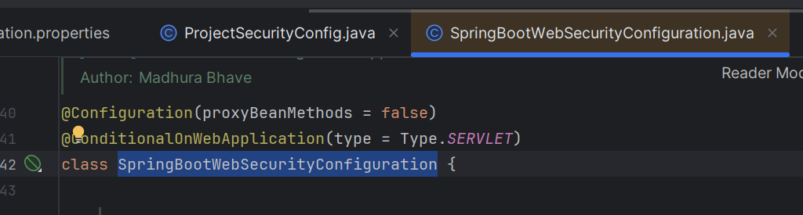

@Bean  
@Order(SecurityProperties.*BASIC_AUTH_ORDER*)  
SecurityFilterChain defaultSecurityFilterChain(HttpSecurity http) throws Exception {  
 http.authorizeHttpRequests((requests) -> requests.anyRequest().authenticated());  
 http.formLogin(*withDefaults*());  
 http.httpBasic(*withDefaults*());  
 return http.build();  
}

**With out Lambda DSL**

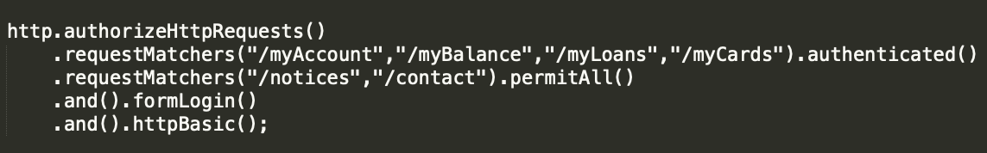

**With Lambda DSL**

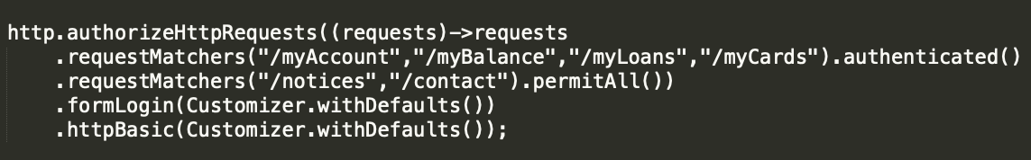

**The Lambda DSL was created to accomplish to following goals:**

* Automatic indentation makes the configuration more readable.
* The is no need to chain configuration options using .and()
* The Spring Security DSL has a similar configuration style to other Spring DSLs such as Spring Integration and Spring Cloud Gateway.

Please refer to the following link for the official note regarding this change from the Spring Security team:

<https://docs.spring.io/spring-security/reference/migration-7/configuration.html>

@Configuration  
public class ProjectSecurityConfig {  
  
 @Bean  
 SecurityFilterChain defaultSecurityFilterChain(HttpSecurity http) throws Exception {  
  
 */**  
 * Below is the custom security configurations  
 */* http.authorizeHttpRequests((requests) -> requests  
 .requestMatchers("/myAccount","/myBalance","/myLoans","/myCards").authenticated()  
 .requestMatchers("/notices","/contact").permitAll())  
 .formLogin(Customizer.*withDefaults*())  
 .httpBasic(Customizer.*withDefaults*());  
 return http.build();

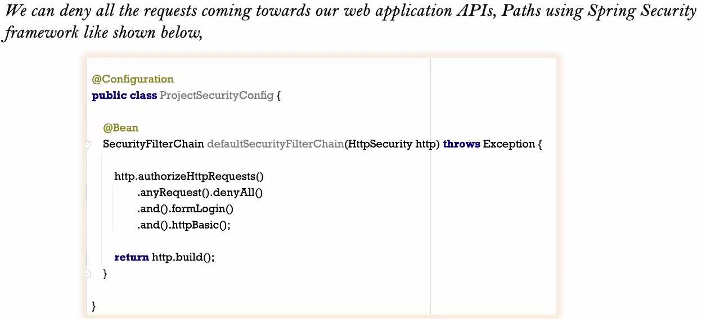

.denyAll – returns 403 error

.permitAll – it will allow all request (not recommended)

Create two beans using Spring boot profile to be used in different environment

How to configure multiple users in in memory

spring.security.user.name = eazybytes  
spring.security.user.password = 12345

Jsession Id (run app, F12, Application) network

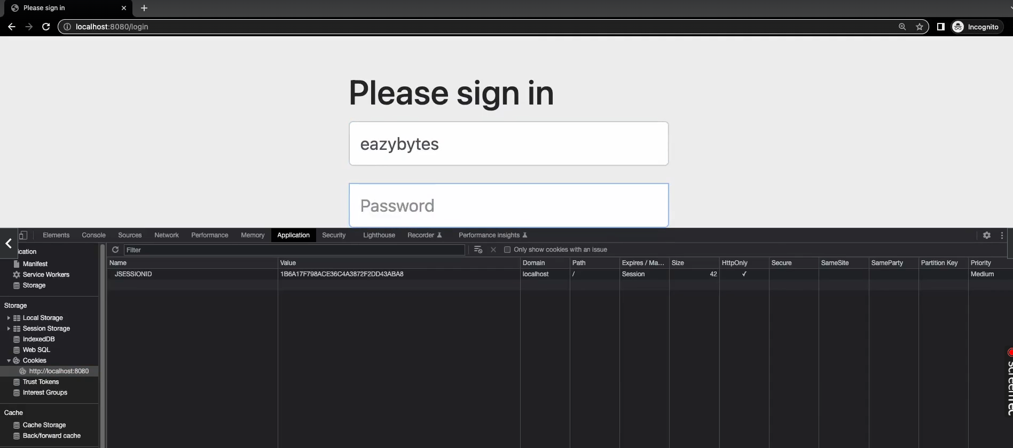

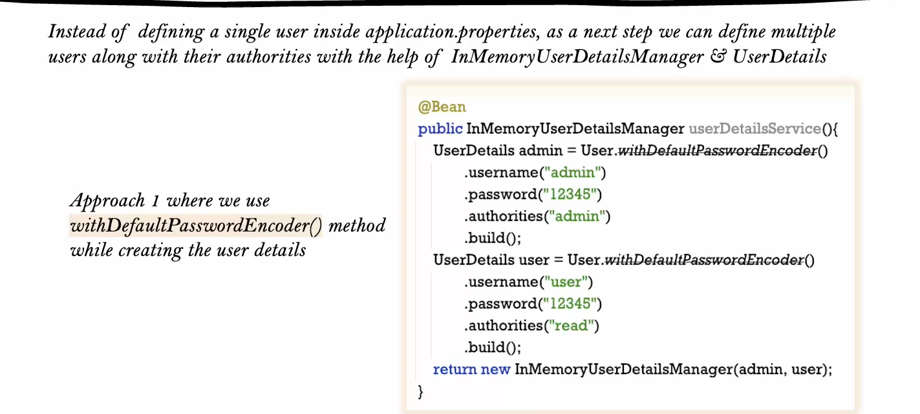

Create new scratch file from selection

*/**  
 * NoOpPasswordEncoder is not recommended for production usage.  
 * Use only for non-prod.  
 *  
 * @return PasswordEncoder  
 */*@Bean  
public PasswordEncoder passwordEncoder() {  
 return NoOpPasswordEncoder.*getInstance*();  
}

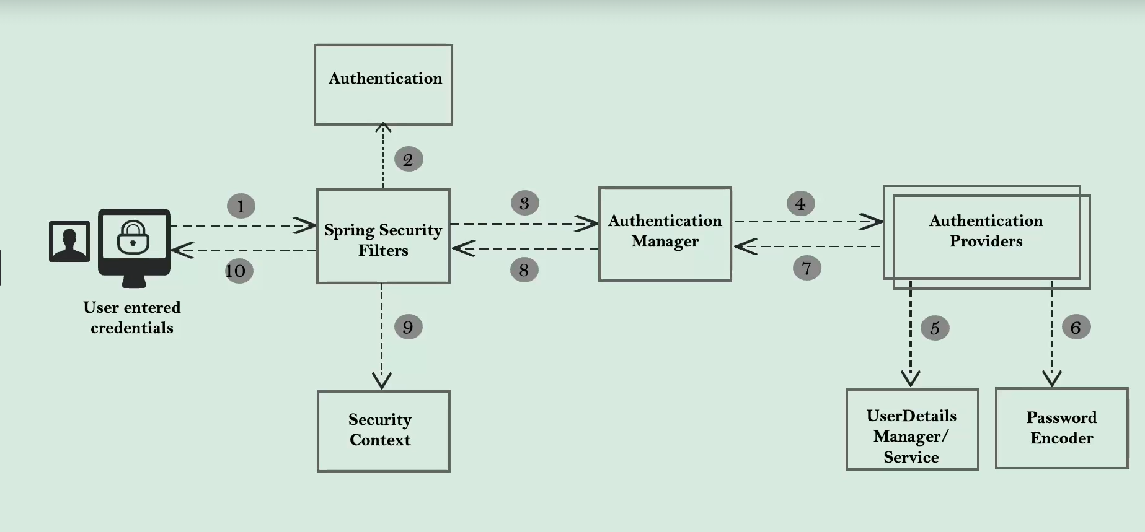

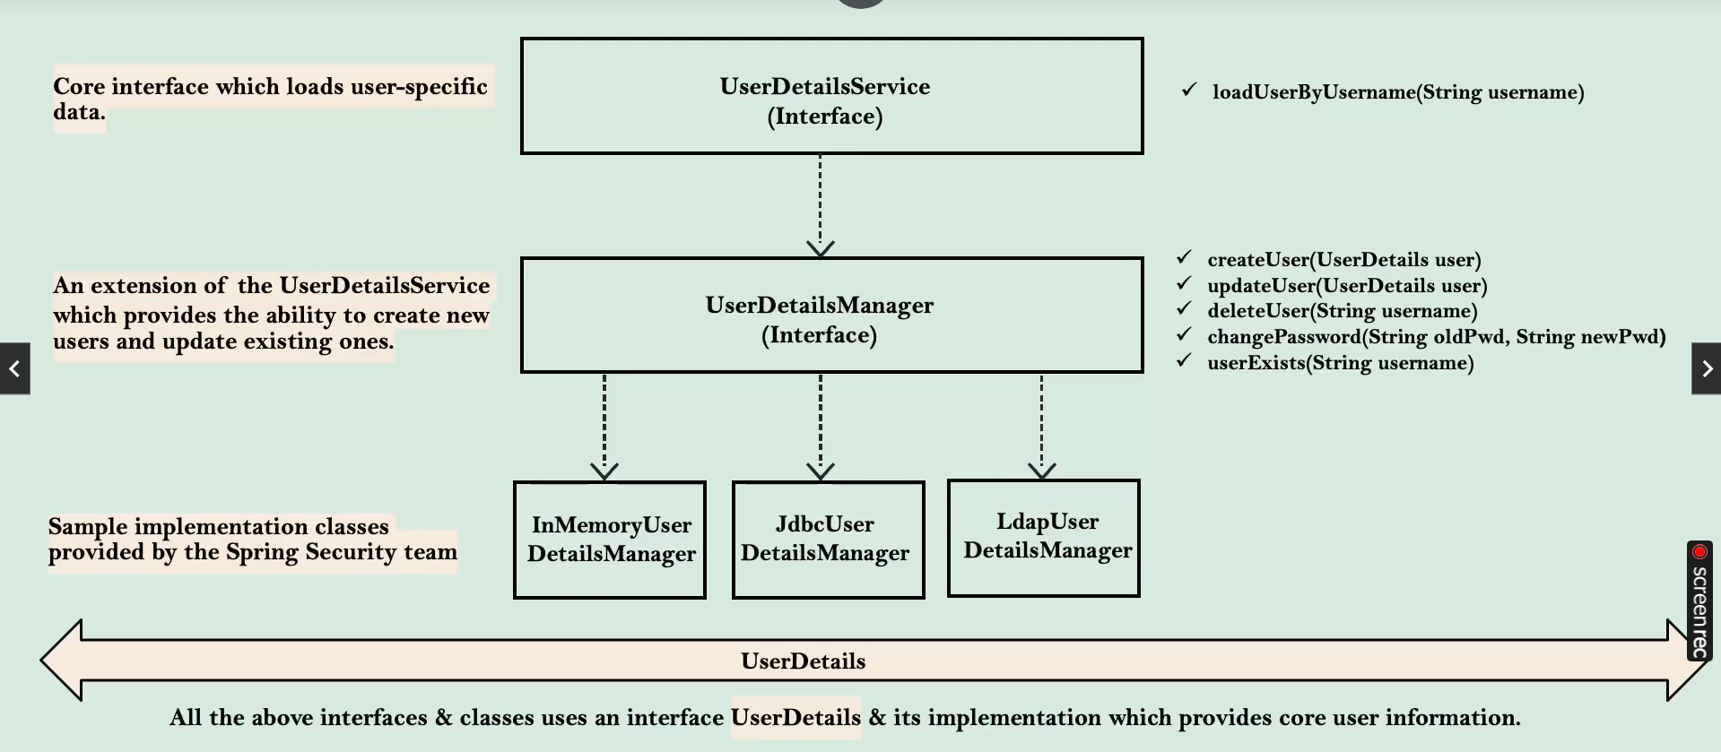

We are creating bean of UserDetailsManager



UserDetailManager has (create, update delete use)

It invokes below method

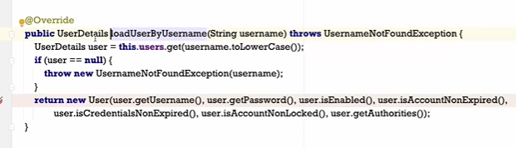

Return type is UserDetails

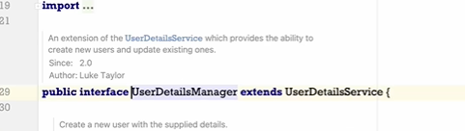

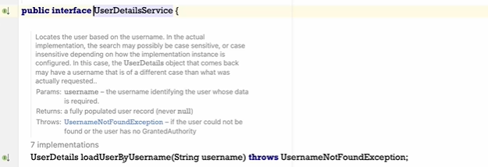

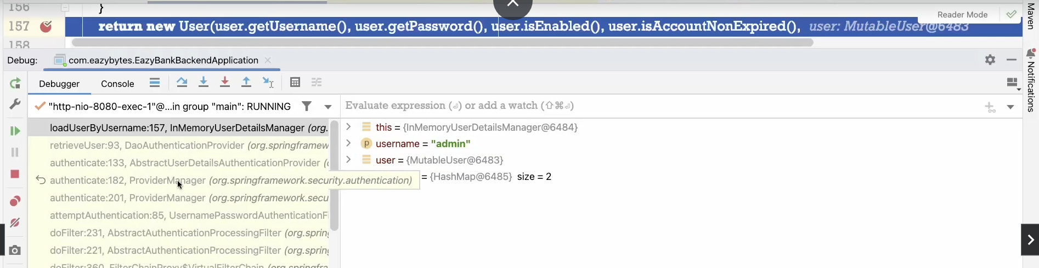

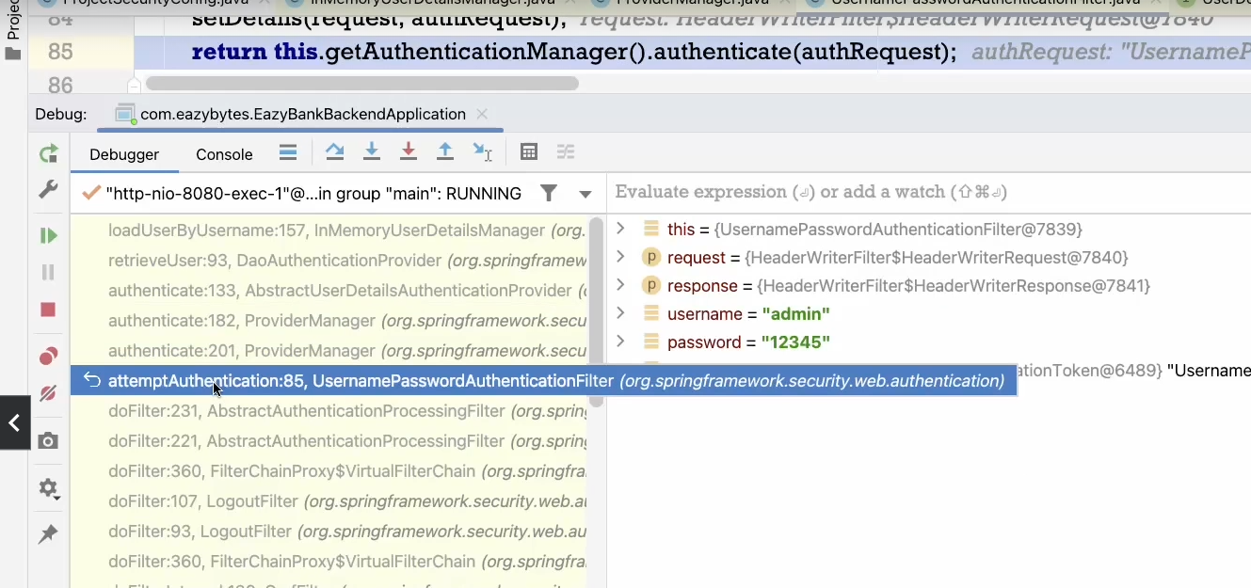

These filters invokes provider manager followed by DAOAuthenticationProvider

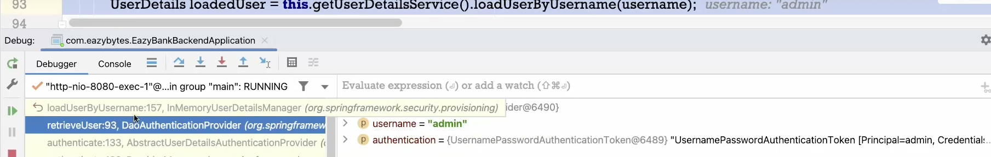

Followed by InmemoryUserDetailsManager

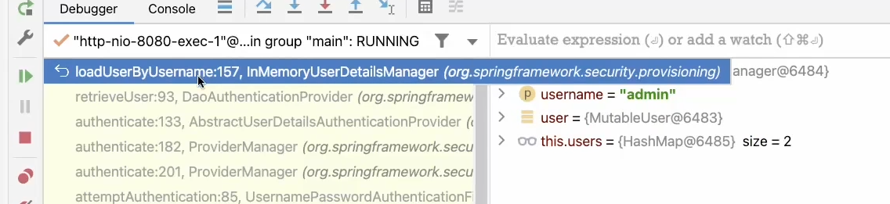

UserDetailsService

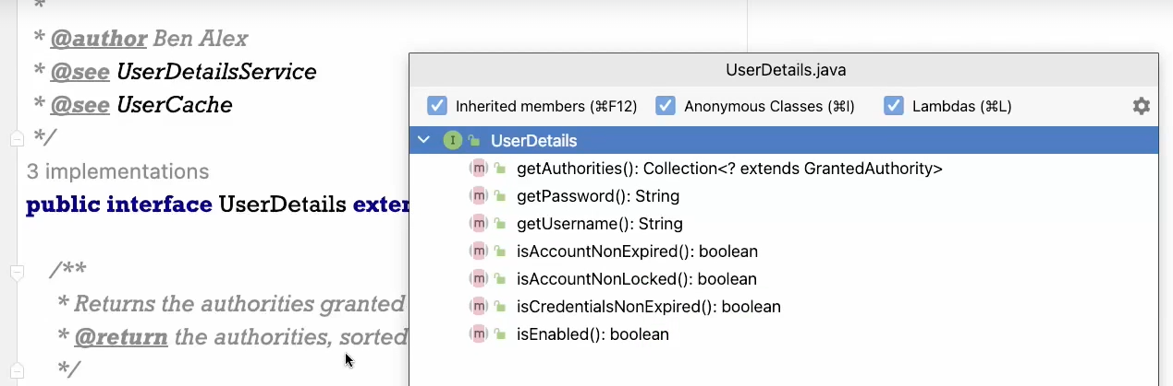

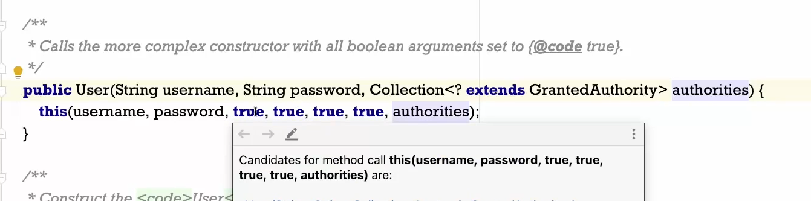

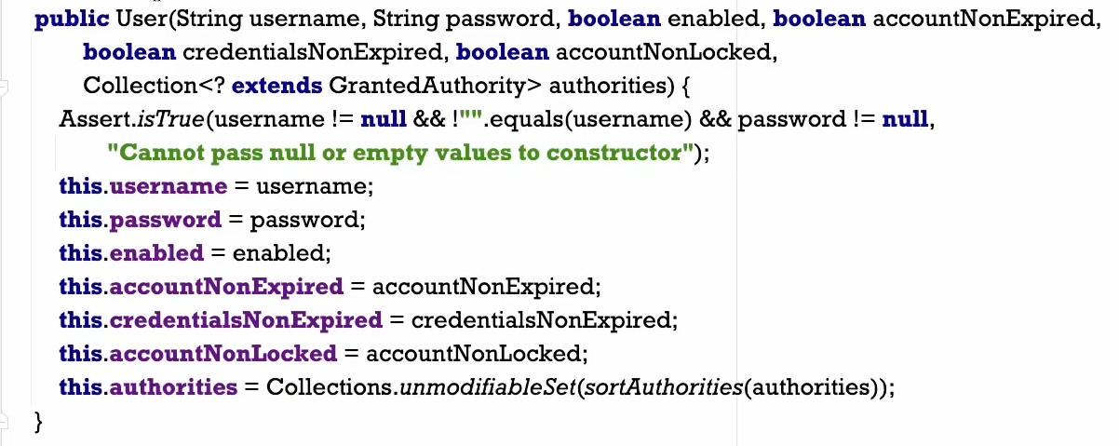

There is no setter method, no one can overwrite it (getUserName, getPassword())

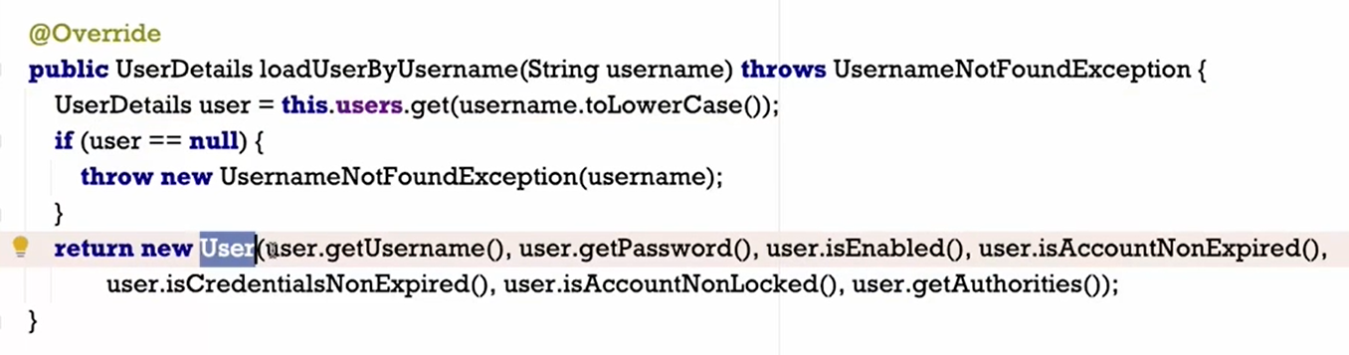

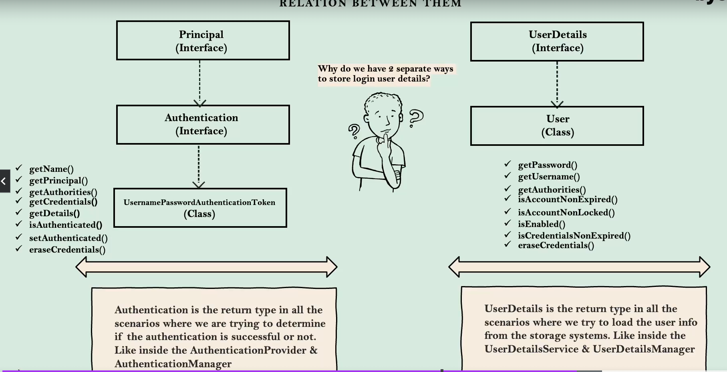

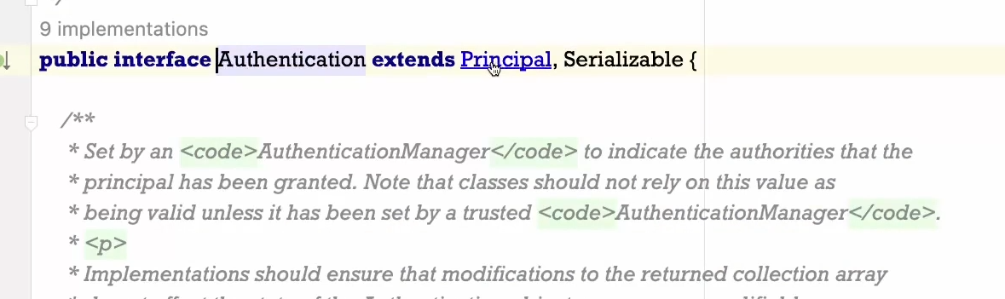

Prinipal is coming from java library

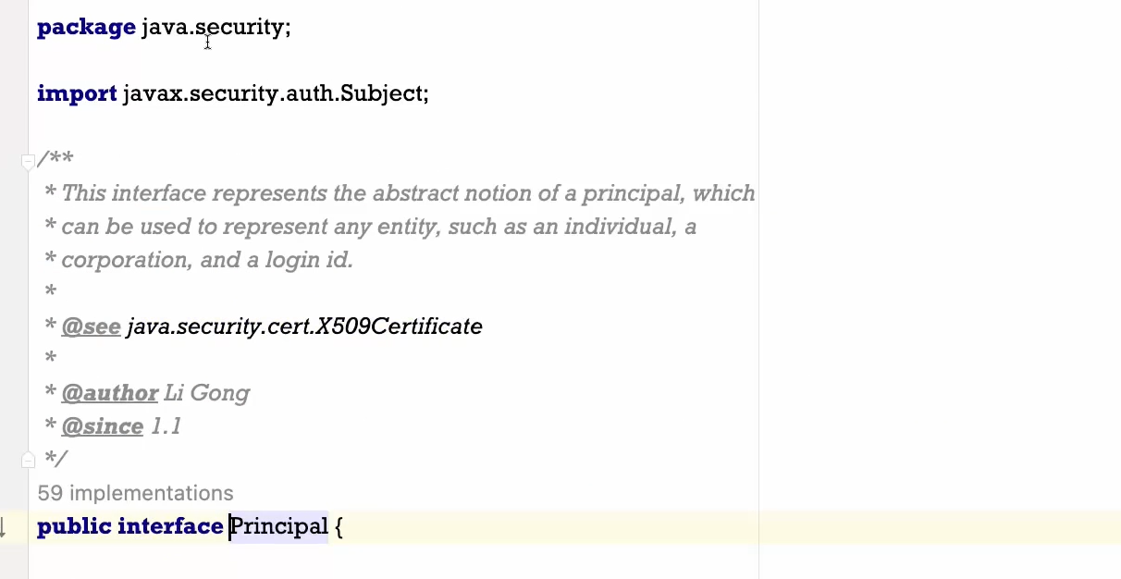

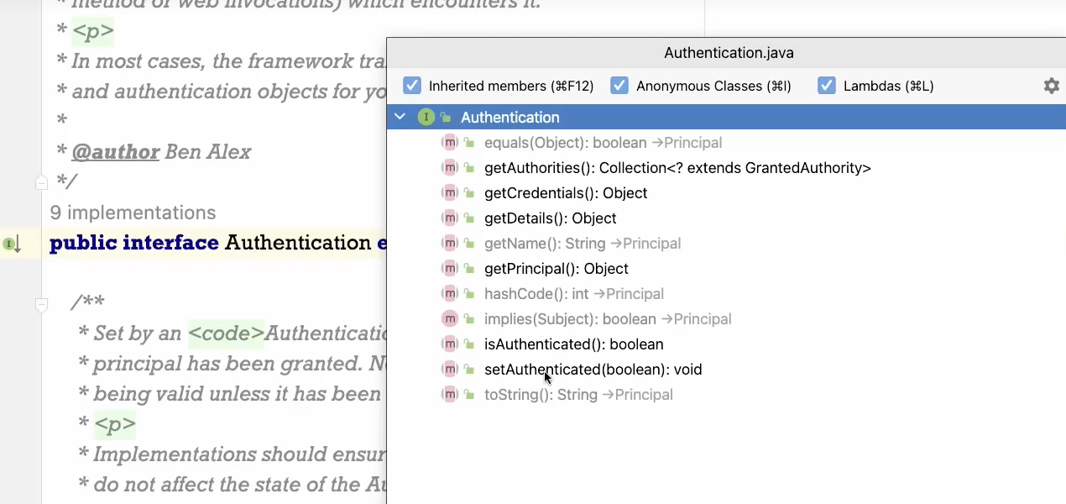

To set the value of Isauthenticated 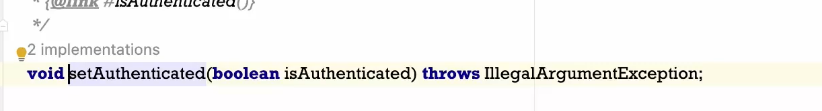

When authentication successful

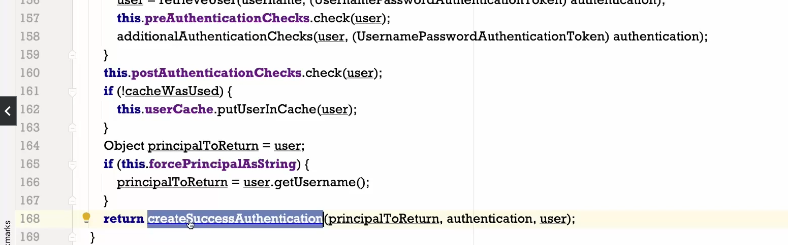

This is going to populate all required details from Userdetails to Authentication and same will be rturned back



UserDetailService – loads the user specific data . Password should not be passed

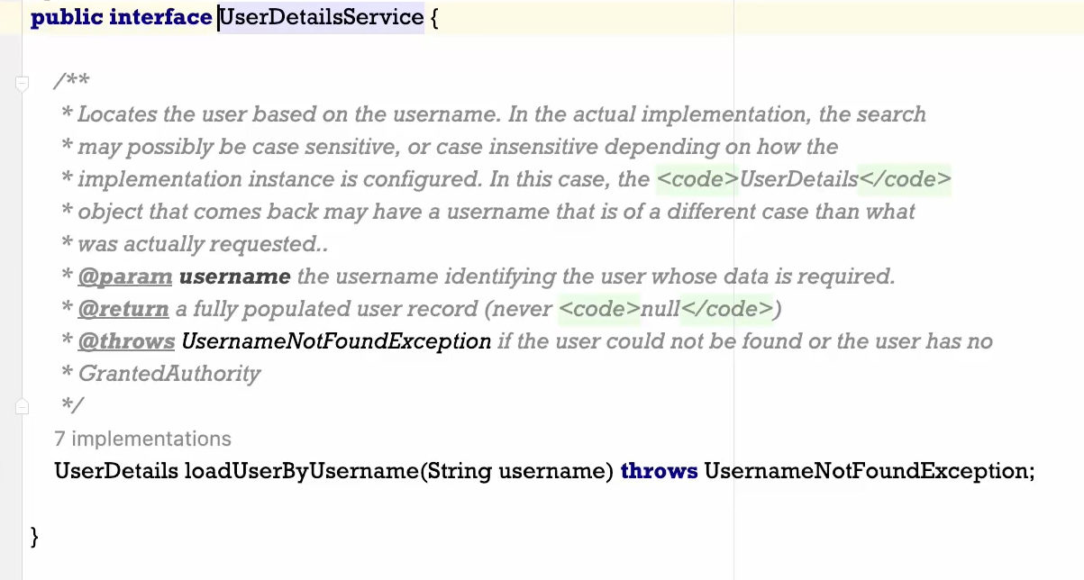

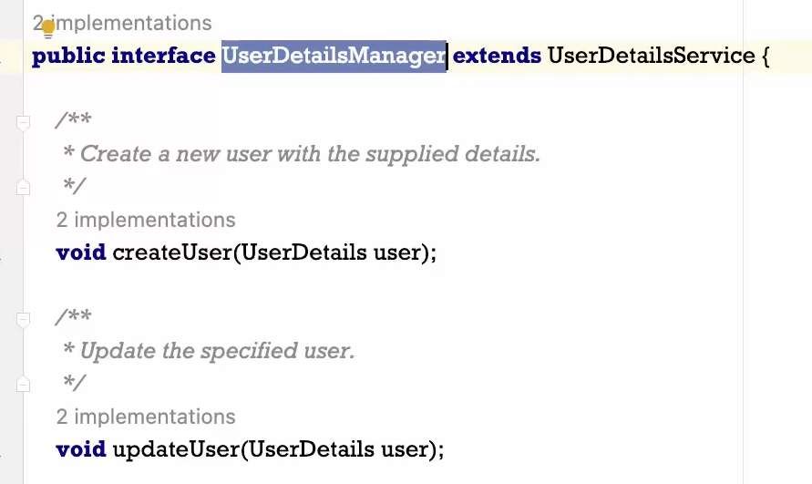

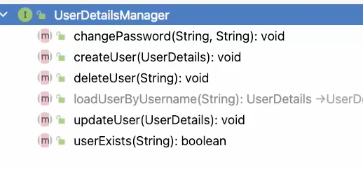

Add these

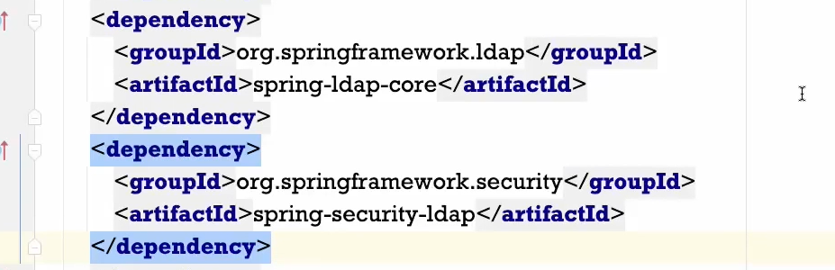

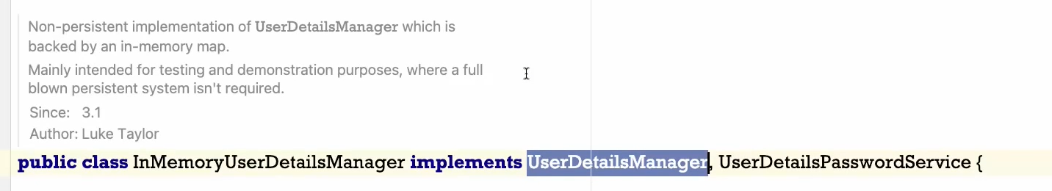

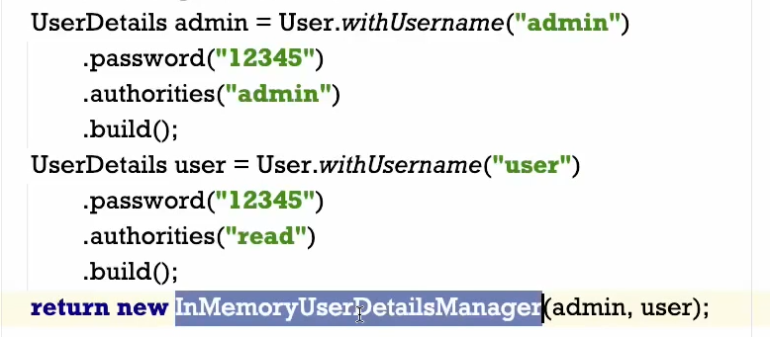

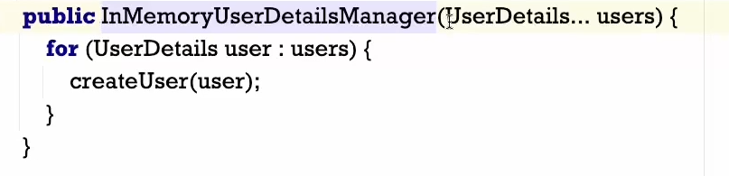

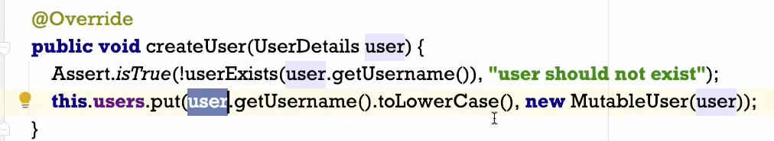

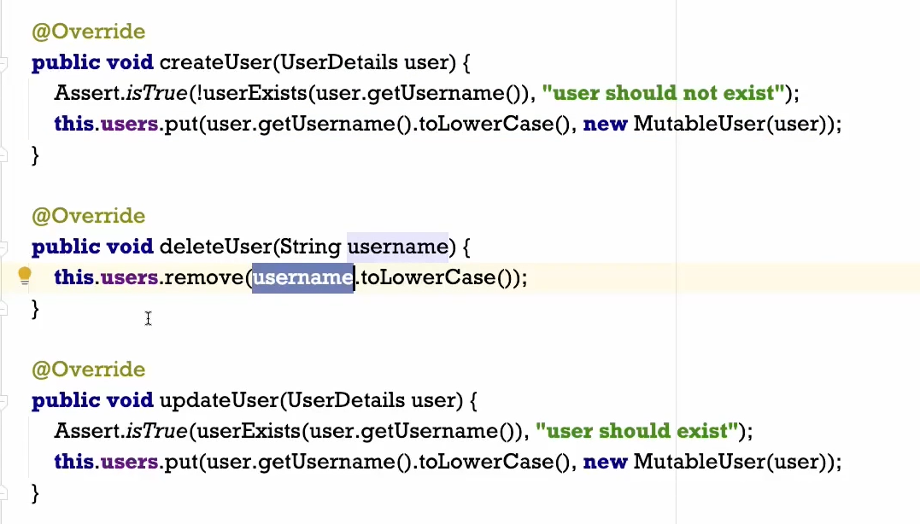

Based on the bean we define same manager will be invoked

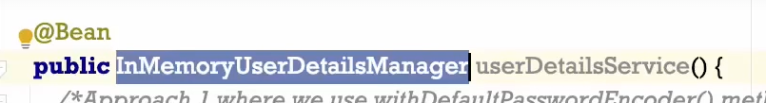

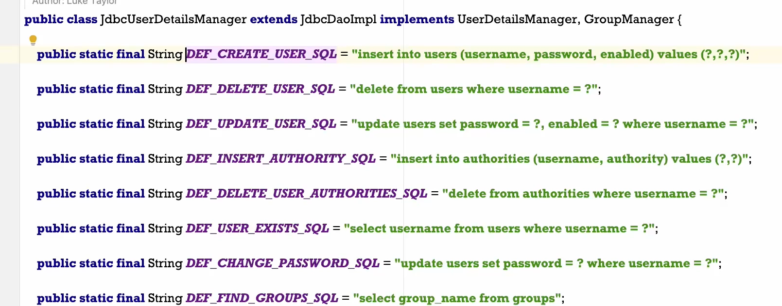



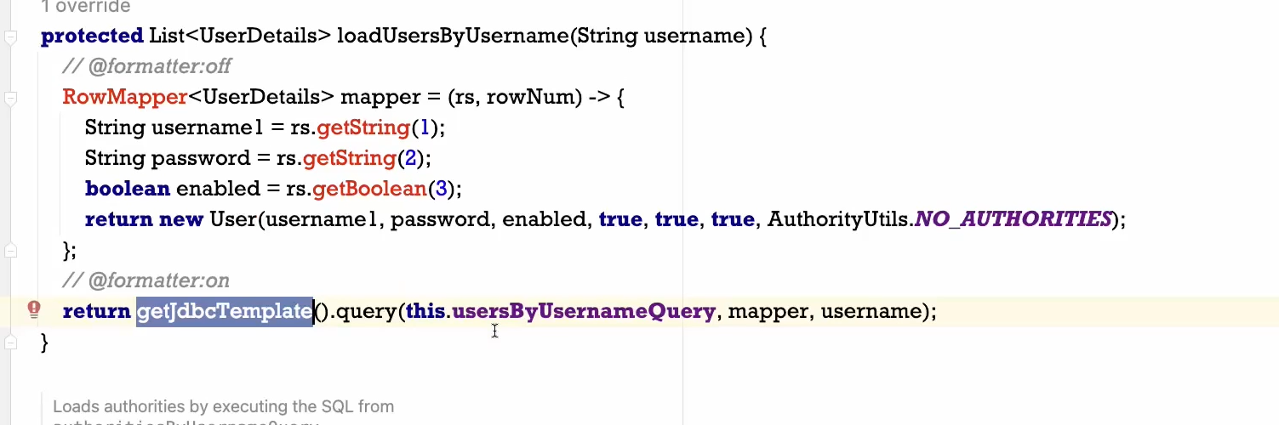

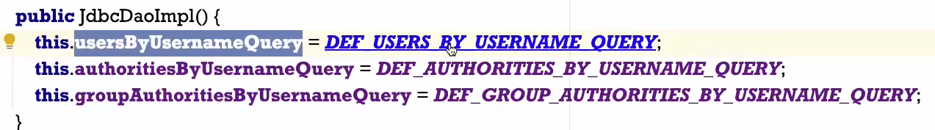

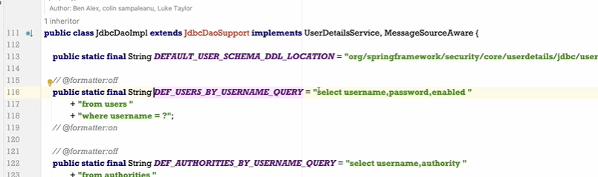

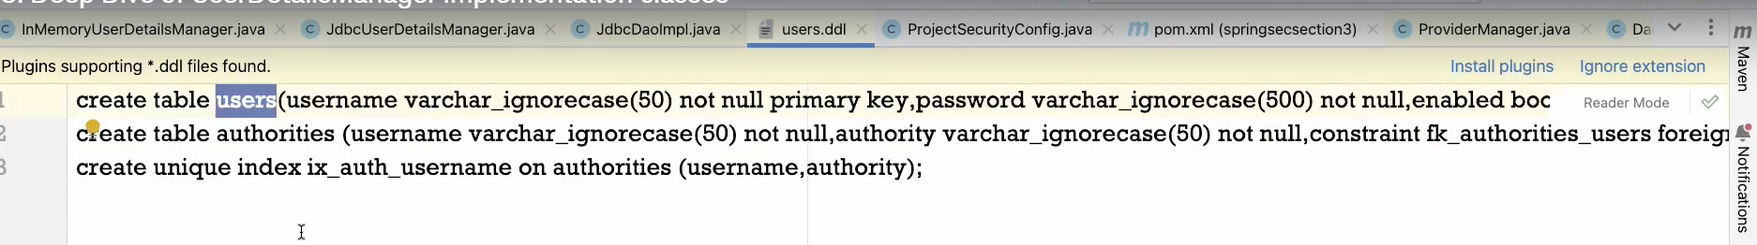

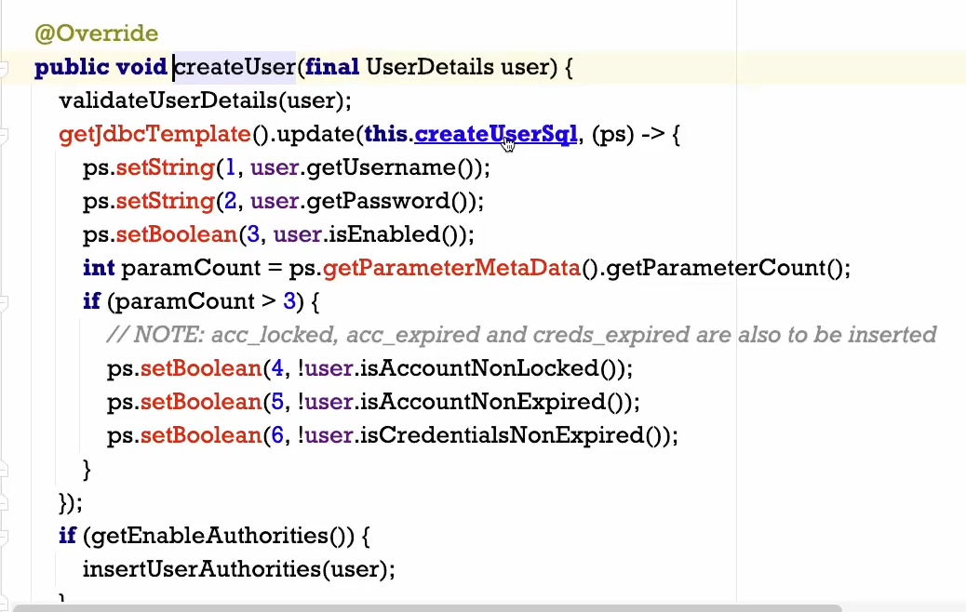

Create users and assign to group

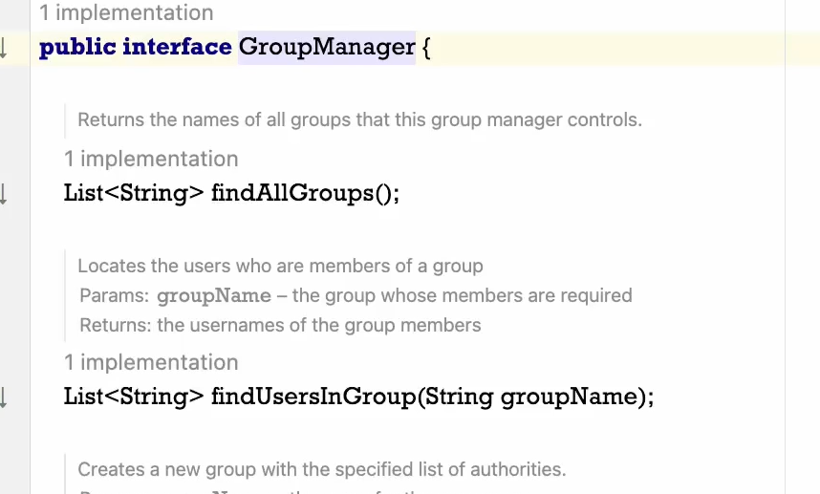

When u are using userDetailManager – follow the same database structure



Not very frequentlyused LDAP –

We have used JDBCUserDetailManagerClass to perform authentication

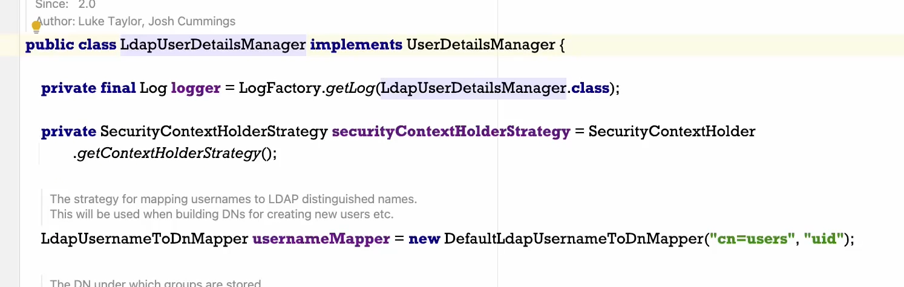

We must have same database structure as UserDetailsServiceManager

In AWS-

RDS (services)

Create Database

Or use Free MySQLHosting

Press Ctrl+Shift+N

Type users.ddl

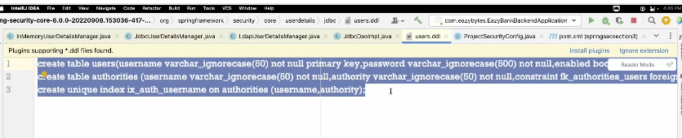

It gives error bcoz it is not properly formatted

create table users(username varchar_ignorecase(50) not null primary key,password varchar_ignorecase(500) not null,enabled boolean not null);  
create table authorities (username varchar_ignorecase(50) not null,authority varchar_ignorecase(50) not null,constraint fk_authorities_users foreign key(username) references users(username));  
create unique index ix_auth_username on authorities (username,authority);

I google type

official documentation of spring security

<https://docs.spring.io/spring-security/reference/index.html>

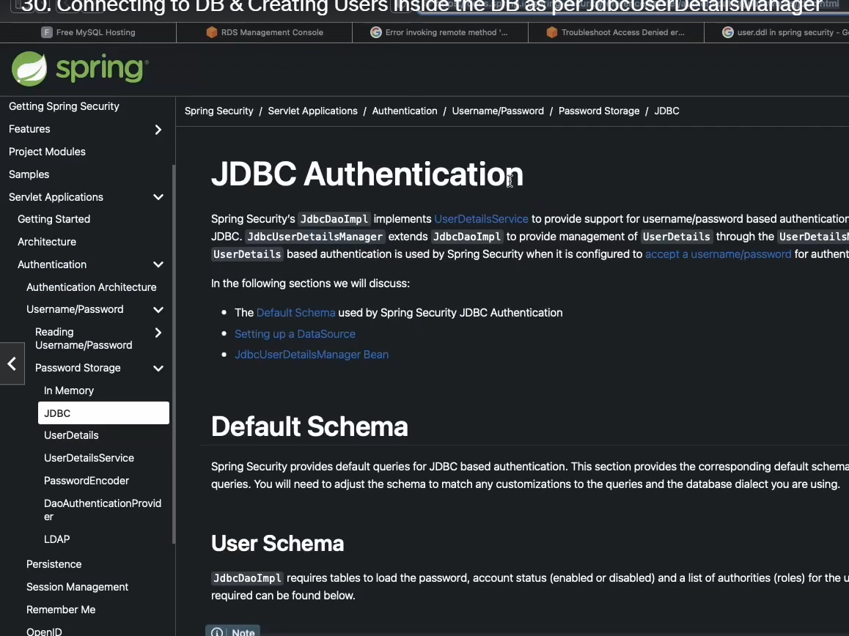

<https://docs.spring.io/spring-security/reference/servlet/authentication/passwords/storage.html>

create table users(

username varchar_ignorecase(50) not null primary key,

password varchar_ignorecase(500) not null,

enabled boolean not null

);

create table authorities (

username varchar_ignorecase(50) not null,

authority varchar_ignorecase(50) not null,

constraint fk_authorities_users foreign key(username) references users(username)

);

create unique index ix_auth_username on authorities (username,authority);

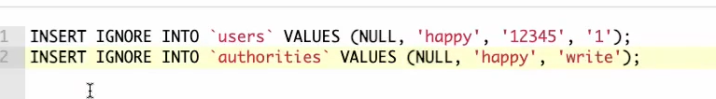

<dependency>  
 <groupId>org.springframework.boot</groupId>  
 <artifactId>spring-boot-starter-jdbc</artifactId>  
</dependency>  
<dependency>  
 <groupId>com.mysql</groupId>  
 <artifactId>mysql-connector-j</artifactId>  
 <scope>runtime</scope>  
</dependency>  
<dependency>  
 <groupId>org.springframework.boot</groupId>  
 <artifactId>spring-boot-starter-data-jpa</artifactId>  
</dependency>